Add Strategy Test Plan

Test Case 1
Create New Strategy (For W_MAIN Session)
- Pick a class which is in two sessions (Options and Futures)
- Create new Strategy for W_MAIN Session
- Verify the newly created Strategy shows up only for the W_MAIN session (not in other sessions).

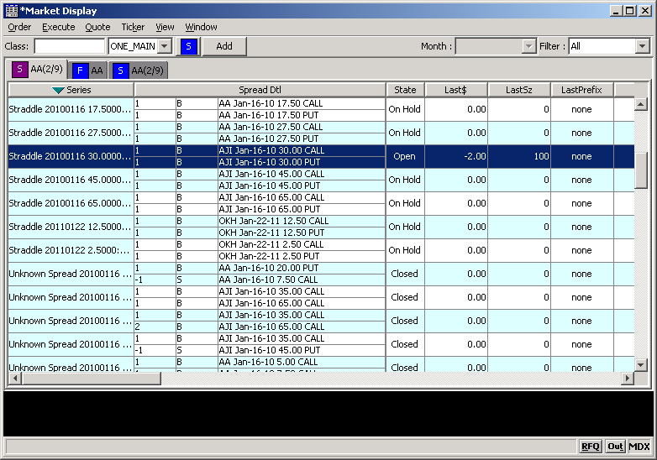

Trade Test on Newly create Strategy

- Change the product state of the newly created strategy from above using SA-GUI
- After opening the Strategy send an Order and do a trade.
- Verify the Fill Report is getting published (Status Window).

Test Case 2
Create New Strategy (ONE_MAIN)
- Pick a class which is in two sessions (W_MAIN and ONE_MAIN), same class should be present in bot the sessions.
- Create new Strategy for ONE_MAIN Session
- Verify the newly created Strategy shows up only for the ONE_MAIN session (not in other sessions).

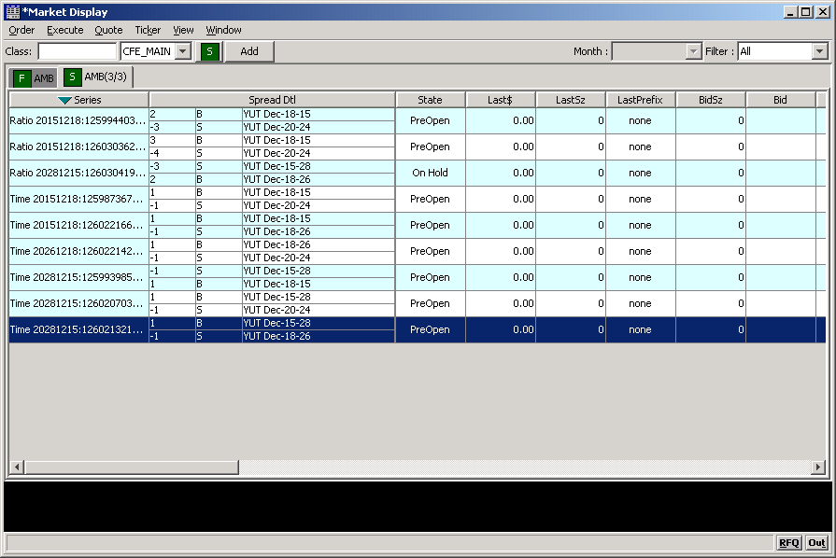

Trade Test on Newly create Strategy

- Change the product state of the newly created strategy from above using SA-GUI
- After opening the Strategy send an Order and do a trade.
- Verify the Fill Report is getting published (Status Window).

Test Case 3
Create New Buy-Write
- Create a Buy-Write
- Change the Product states
- Route and Order and do a trade.
- Verify the Fill Report is getting published.

